ELE222E INTRODUCTION TO ELECTRONICS (20521)

Midterm Exam #2  19 April 2010  11.30-13.30

İnci ÇİLESİZ, PhD, Nazan İLTÜZER, BSE

- Assuming all capacitors are ideal, study the two stage circuit below for ß = h_{FE} = h_{fe} = 150,
h_{oe} = h_{re} = 0, V_{T} = 25 mV, and |V_{BE}|= 0,6 V. Find collector currents, voltage gain v_{o}/v_{s}, r_{i}, and r_{o}.
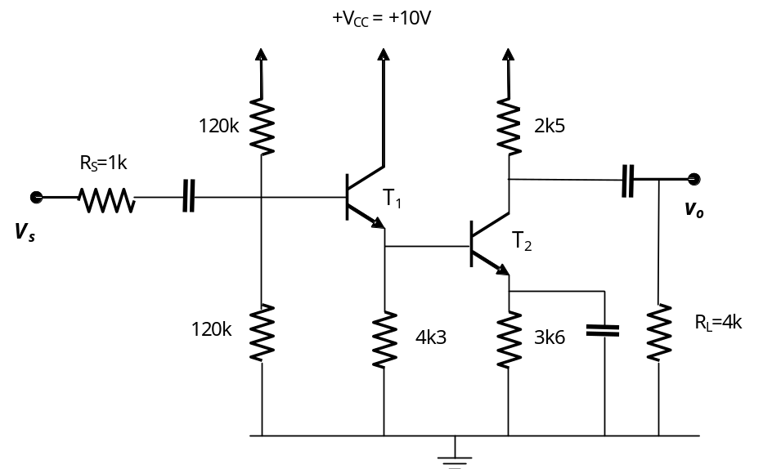
HINT: While calculating collector currents you will obtain 2 loop equations with 2 unknowns!
- Now that you studied Problem 1, analyze the circuit below for ß = h_{FE} = h_{fe} = 100, V_{T} = 25 mV,
h_{oe} = h_{re} = 0, and |V_{BE}|= 0,6 V. Find the value of R_{C4} such that, I_{C1} = I_{C2} = 0,5 mA, and the voltage swing at the output (V_{o}) is symmetric. If you design a current mirror that will provide the current to the first stage you may earn 10 bonus points.
Calculate voltage gain v_{o}/v_{in}, r_{i}, r_{o}, and finally CMRR of the first stage. (60 points)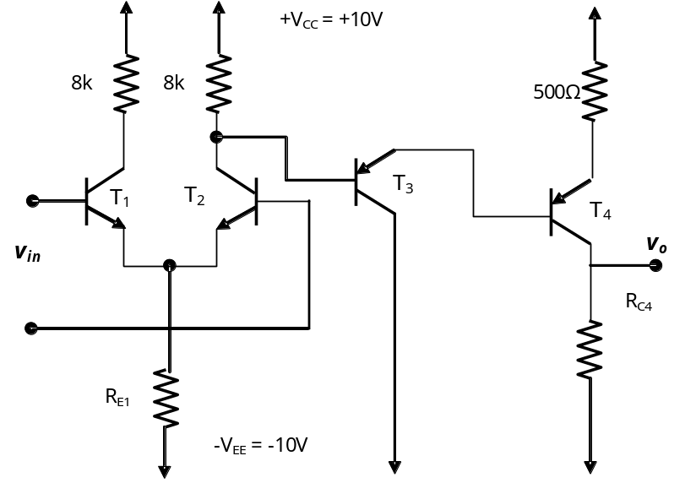
SOLUTIONS:
1. With ideal capacitors load and source resistors are isolated for biasing purposes. Thus using Thevenin Eq. circuit: R_{BB} = 60K, V_{BB} = 5V and
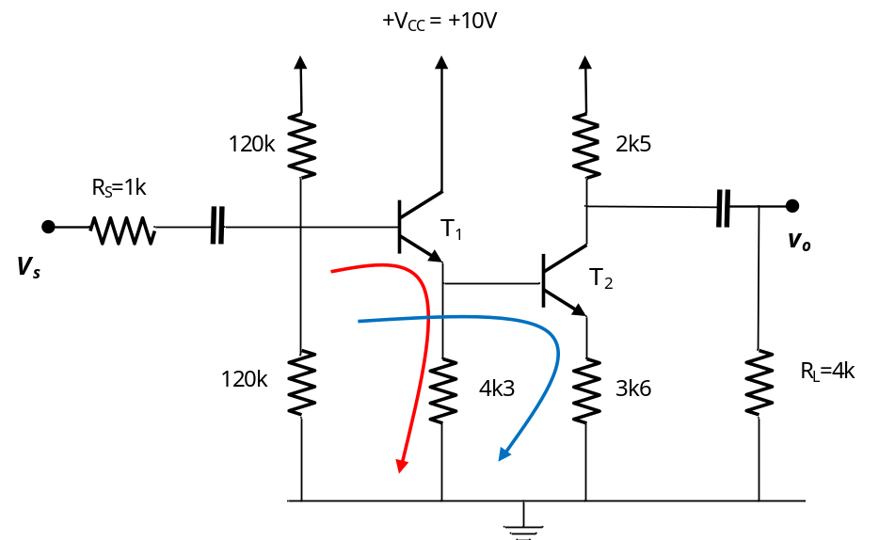
Red loop:
Blue loop:
From blue loop: 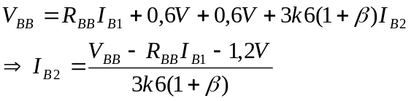
Insert I_{B2} into red loop:
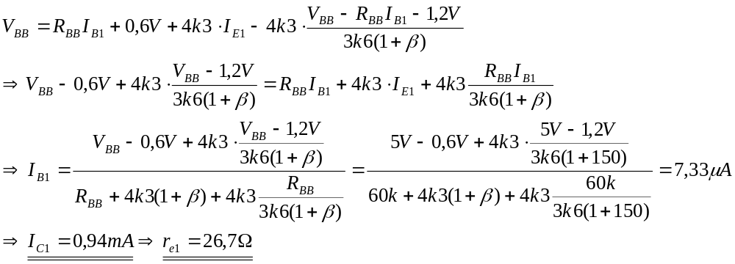
Insert this value into 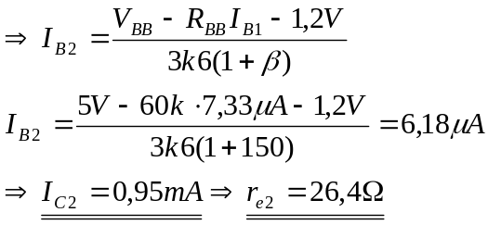
Now we can do AC analysis:
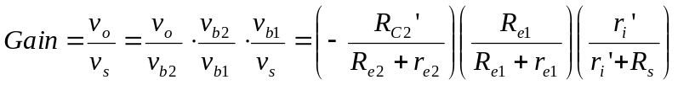
Where 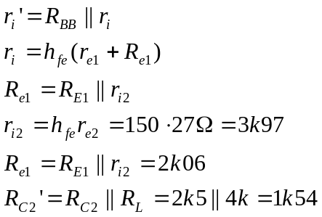
Realize that R_{E2} is shunted.
Thus 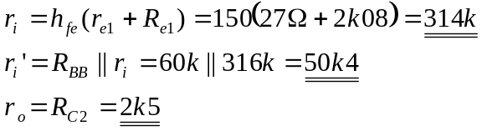
Finally:
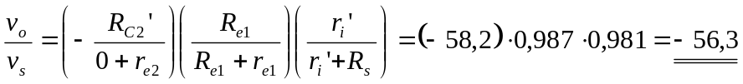

2. Since I_{C1} = I_{C2} = I_{C} = 0,5 mA, 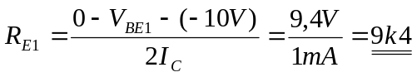
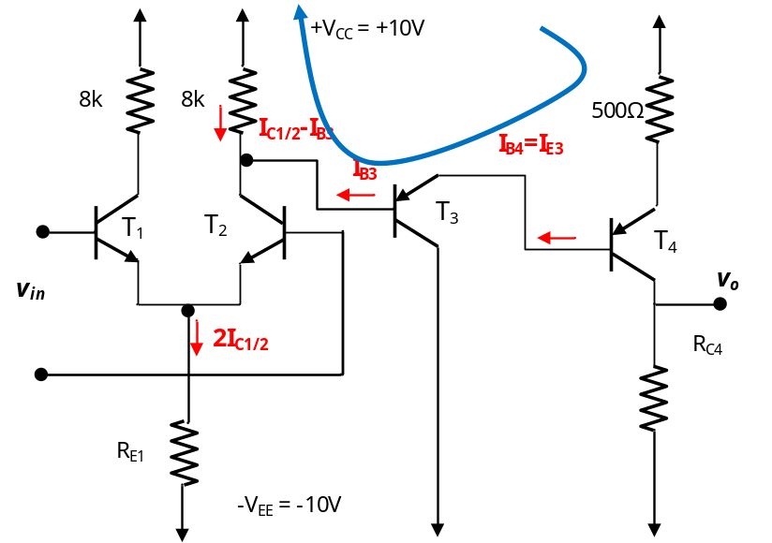

Blue loop: 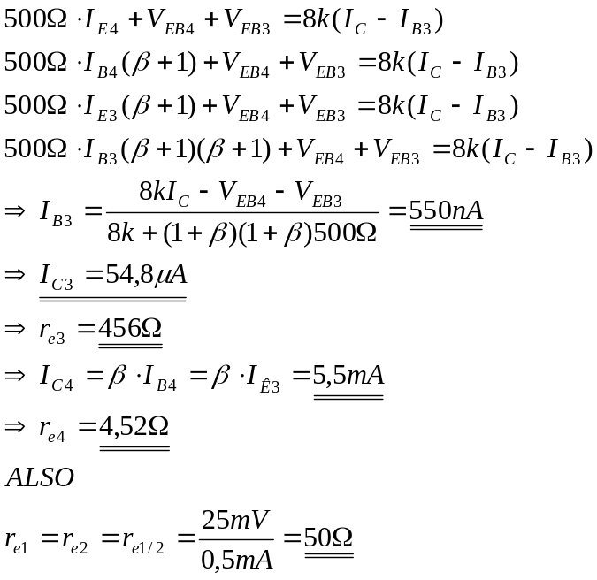
Now that V_{o} = 0V should be satisfied: 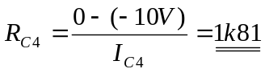
AC analysis:
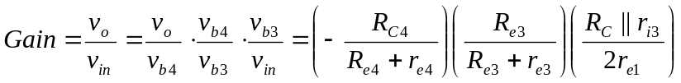
Where 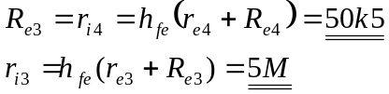
Also 